Point Clipping:

Point Clipping is used to determining, whether the point is inside the window or not. For this following conditions are checked.

1. x ≤ xmax
2. x ≥ xmin
3. y ≤ ymax
4. y ≥ ymin

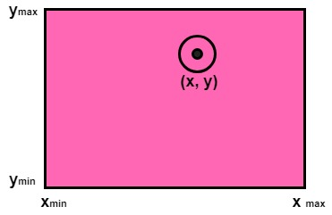

The (x, y) is coordinate of the point. If anyone from the above inequalities is false, then the point will fall outside the window and will not be considered to be visible.

Program1:

**To implement Point Clipping:**

1. #include<stdio.h>
2. #include<conio.h>
3. #include<graphics.h>
4. inttlx,tly,brx,bry,px,py;
5. **void** point_clip()
6. {
7. intwxmin,wymin,wxmax,wymax;
8. wxmin=tlx;
9. wxmax=brx;
10. wymin=tly;
11. wymax=bry;
12. **if**(px>=wxmin&&px<=wxmax)
13. **if**(py>=wymin&&py<=wymax)
14. putpixel(px,py,RED);
15. getch();
16. closegraph();
17. }
18. **void** main()
19. {
20. intgd=DETECT,gm,xc,yc,r;
21. clrscr();
22. printf("Enter the top left coordinate");
23. scanf("%d%d",&tlx,&tly);
24. printf("Enter the bottom right coordinate");
25. scanf("%d%d",&brx,&bry);
26. printf("\n Enter the point");
27. scanf("%d%d",&px,&py);
28. initgraph(&gd,&gm,"c:\\tc\\bgi");
29. setbkcolor(BLUE);
30. setcolor(RED);
31. rectangle(tlx,tly,brx,bry);
32. point_clip();
33. }

**Output:**

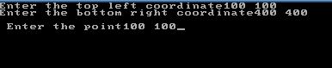



Program2:

**To implement point clipping with respect to rectangular window:**

1. #include<stdio.h>
2. #include<conio.h>
3. #include<graphics.h>
4. **void** main()
5. {
6. **int** gm,gr,xcmin,ycmin,xcmax,ycmax,x,y,c;
7. clrscr();
8. detectgraph(&gm,&gr);
9. initgraph(&gm,&gr,"c:\\tc\\BGI");
10. printf("Enter the clipmin coordinate :\n");
11. scanf("%d%d",&xcmin,&ycmin);
12. printf("Enter the clipmax coordinate :\n");
13. scanf("%d%d",&xcmax,&ycmax);
14. rectangle(xcmin,ycmax,xcmax,ycmin);
15. printf("Enter the coordinate of the point:\n");
16. scanf("%d%d",&x,&y);
17. detectgraph(&gm,&gr);
18. initgraph(&gm,&gr,"c:\\tc\\BGI");
19. putpixel(x,y,15);
20. printf("\n1.Point clipping\n2.Exit\nEnter your choice:\n");
21. scanf("%d",&c);
22. **switch**(c)
23. {
24. **case** 1:
25. detectgraph(&gm,&gr);
26. initgraph(&gm,&gr,"d:\\tc\\BGI");
27. rectangle (xcmin,ycmax,xcmax,ycmin);
28. printf("*******POINT CLIPPING******\n");
29. **if** ((xcmin<x) && (x<xcmax))
30. {
31. **if** ((ycmin<y) && (y<ycmax))
32. {
33. printf("The point is inside the clip window\n");
34. putpixel(x,y,15);
35. }
36. }
37. **else**
38. printf("The point is outside the clipwindow \nThe point is clipped\n");
39. **break**;
40. **case** 2: exit(0);
41. }
42. getch();
43. }

**Output:**

